**5. Assembly Guide**

After making an inventory all the parts in this kit, then we need to mount the tank robot. Let’s install smart car in compliance with the following instructions.

**Note: Peel the plastic film off the board first when installing smart car.**

Step 1: Install Bottom Motor

Prepare the parts as follows:

* M4 Nut * 2
* Metal Motor *2
* Metal Holder *2
* Copper Coupler *2
* Blue Supportive Parts *2
* M4*12MM Inner Hex Screw * 2
* M1.5 Hex Key Nickel Plated Allen Wrench *1
* M3 Hex Key Nickel Plated Allen Wrench *1
* M2.5 Hex Key Nickel Plated Allen Wrench *1
* M3*8MM Inner Hex Screw * 4

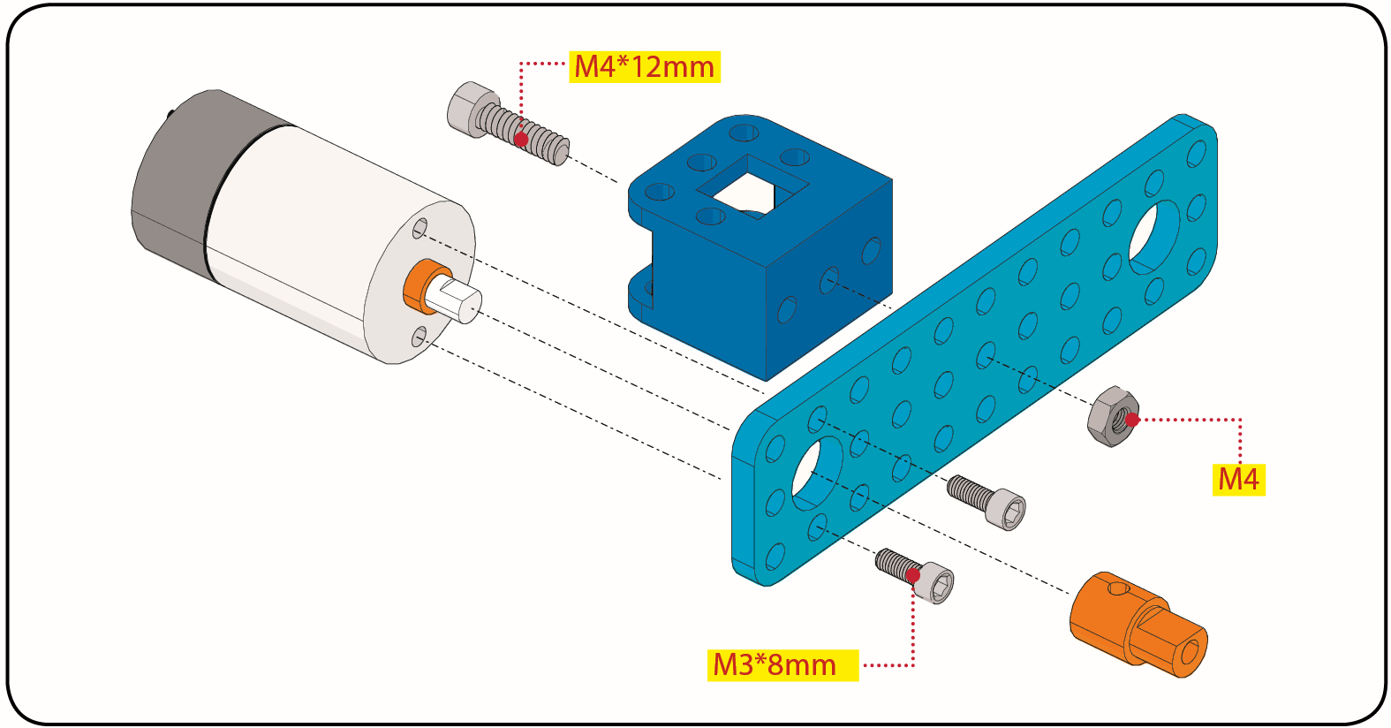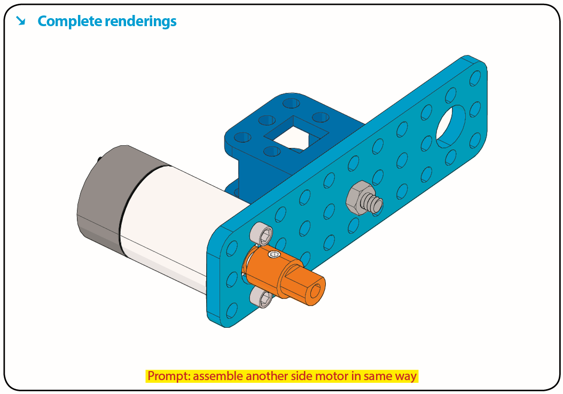

Step 2: Install Driver Wheel

Prepare the parts as follows:

* M4*12MM Inner Hex Screw * 2
* M4*50MM Inner Hex Screw * 2
* Tank Load-bearing Wheel * 2
* Flange Bearing * 4
* Copper Bush *2
* Caterpillar Band *2
* M4 Self-locking Nut * 2
* M3 Hex Key Nickel Plated Allen Wrench *1

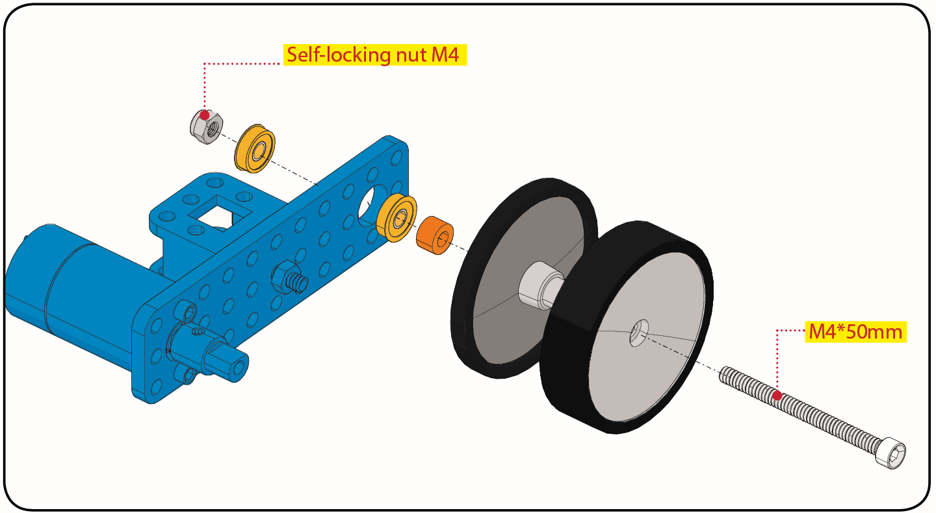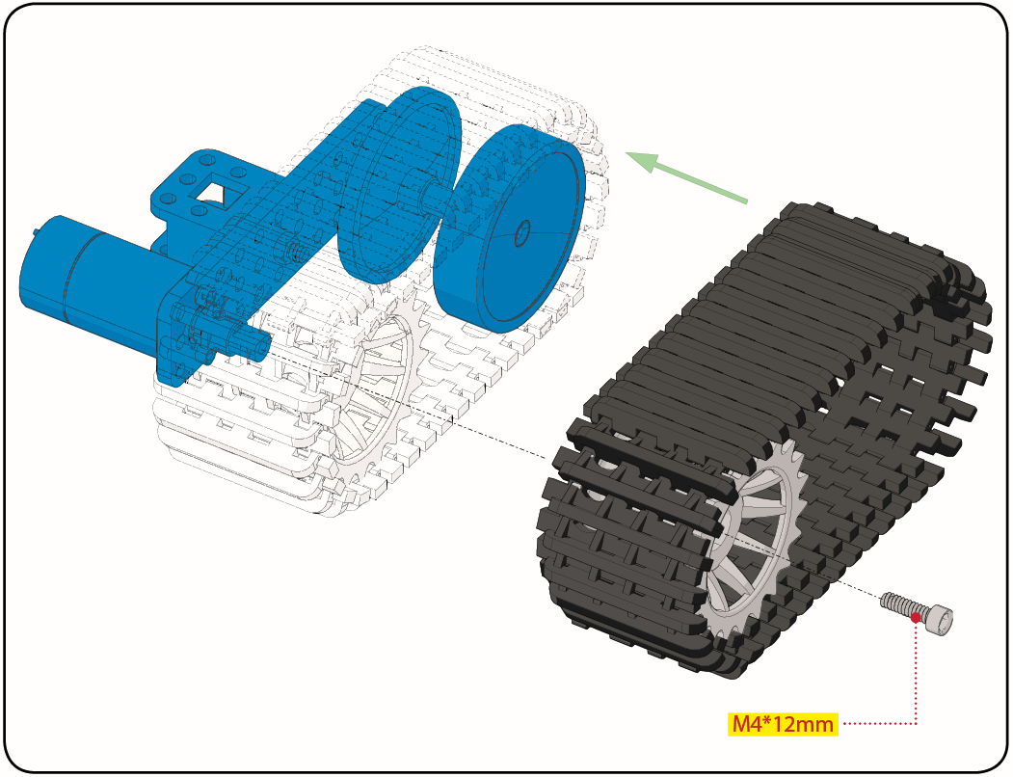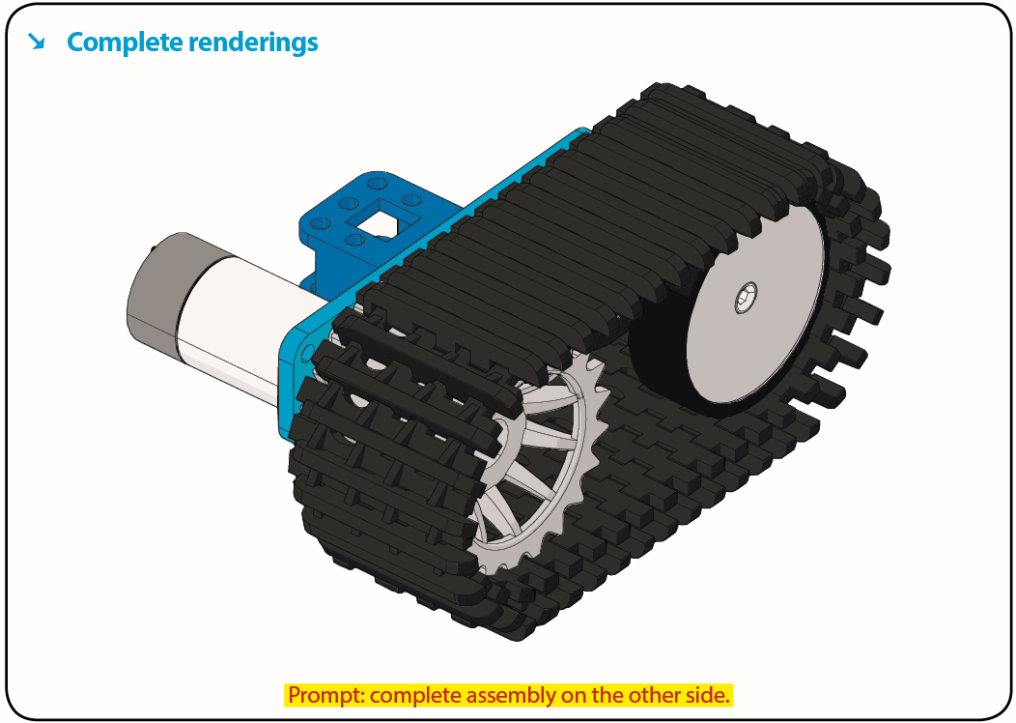

Step 3: Install the Battery Holder

Prepare the parts as follows:

* Battery Holder *1
* M3 Nut * 2
* Blue Metal holder *2
* M4 Nut *8
* M3*10MM Flat Head Screw * 2
* M4*40MM Inner Hex Screw *4
* M2.5 Hex Key Nickel Plated Allen Wrench*1
* M3 Hex Key Nickel Plated Allen Wrench *1
* M3*25MM Inner Hex Screw *4

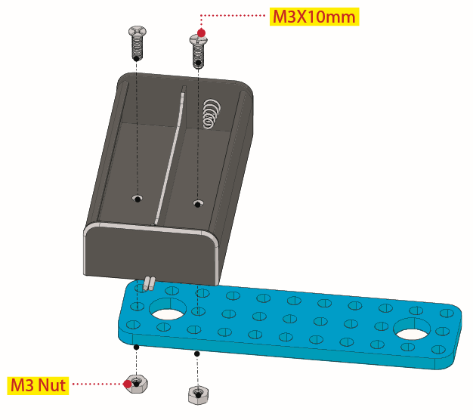

Finish the mount process. Go to fix the metal holder on the motor wheel with four M4*40MM inner hex screws and four M4 nuts.

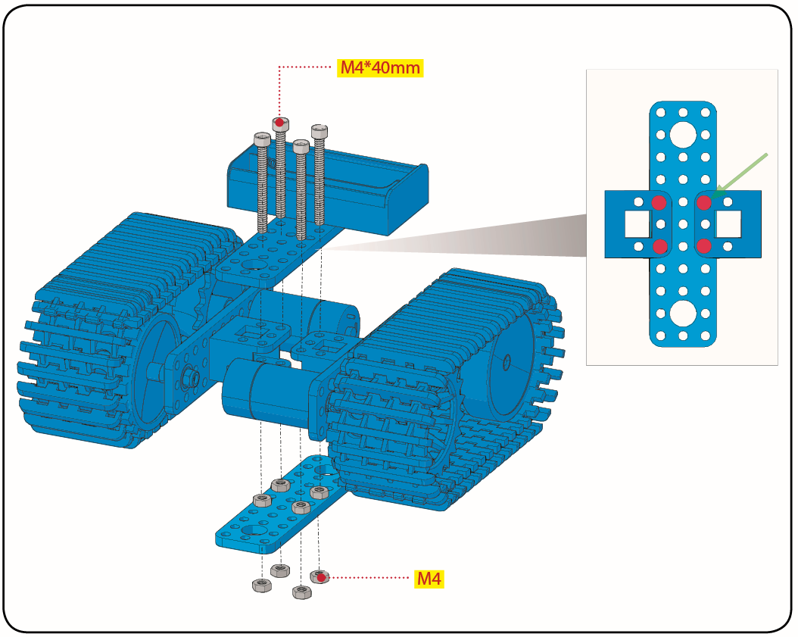

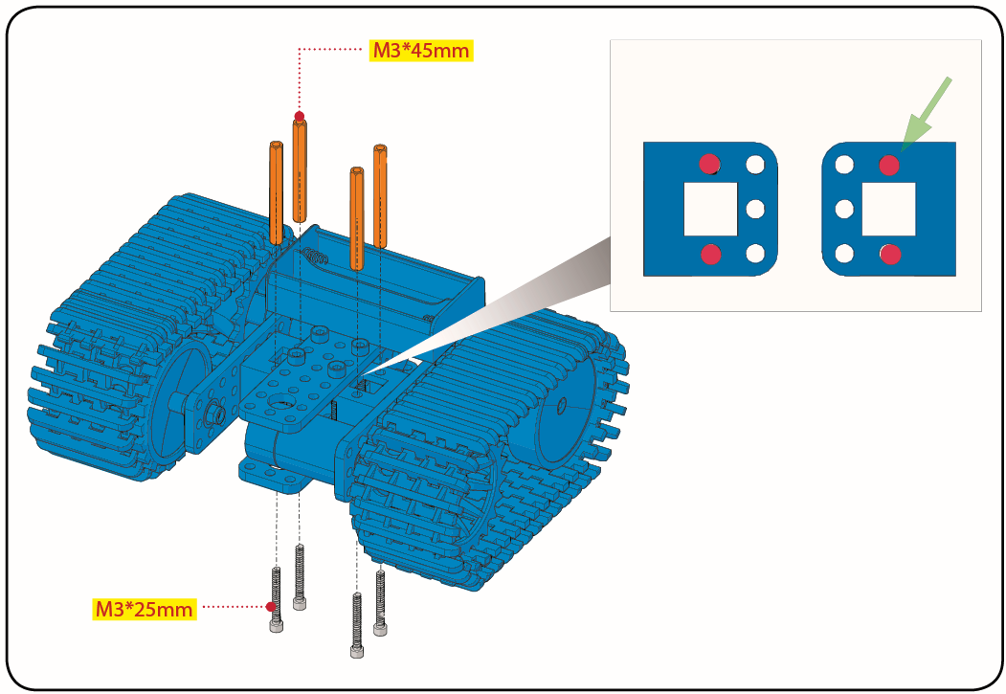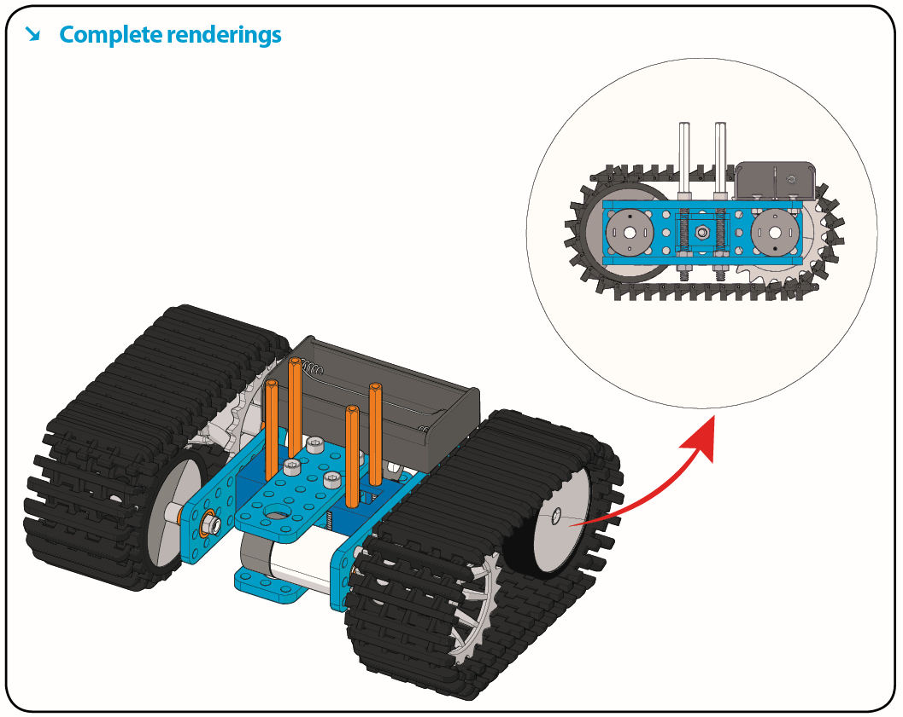

Step 4: Mount Acrylic Board and Sensors

* Acrylic Board * 2
* L- type Black Bracket *1
* Photocell Sensor *2
* IR Receiver Module *1
* 8X16 LED Panel *1
* M2 Nut *4
* M3 Nut *10
* M3*6MM Inner Hex Screw * 8
* M2.5 Hex Key Allen Wrench *1
* M3*12MM Round Head Screw *7
* M3*10MM Hexagon Copper Bush *8
* M2*10MM Round Head Screw * 4

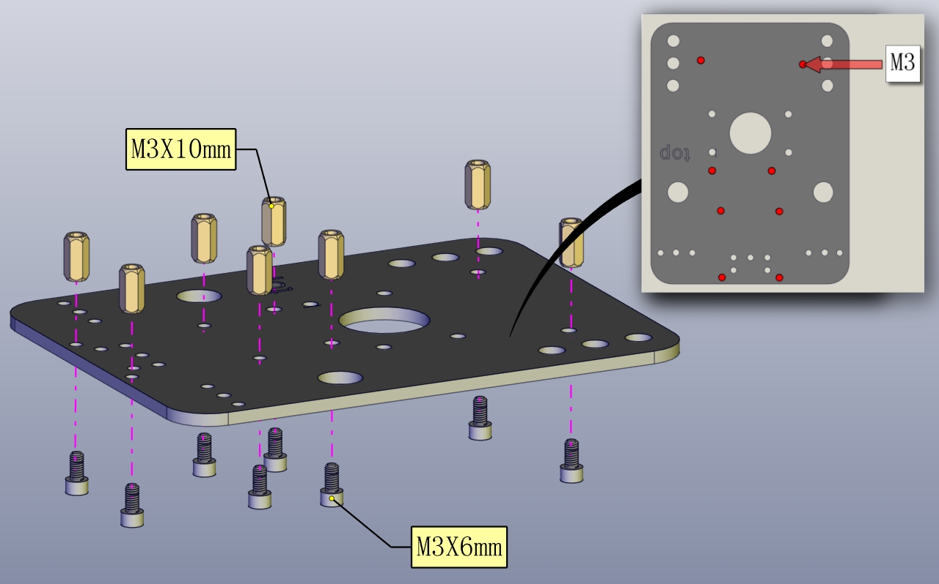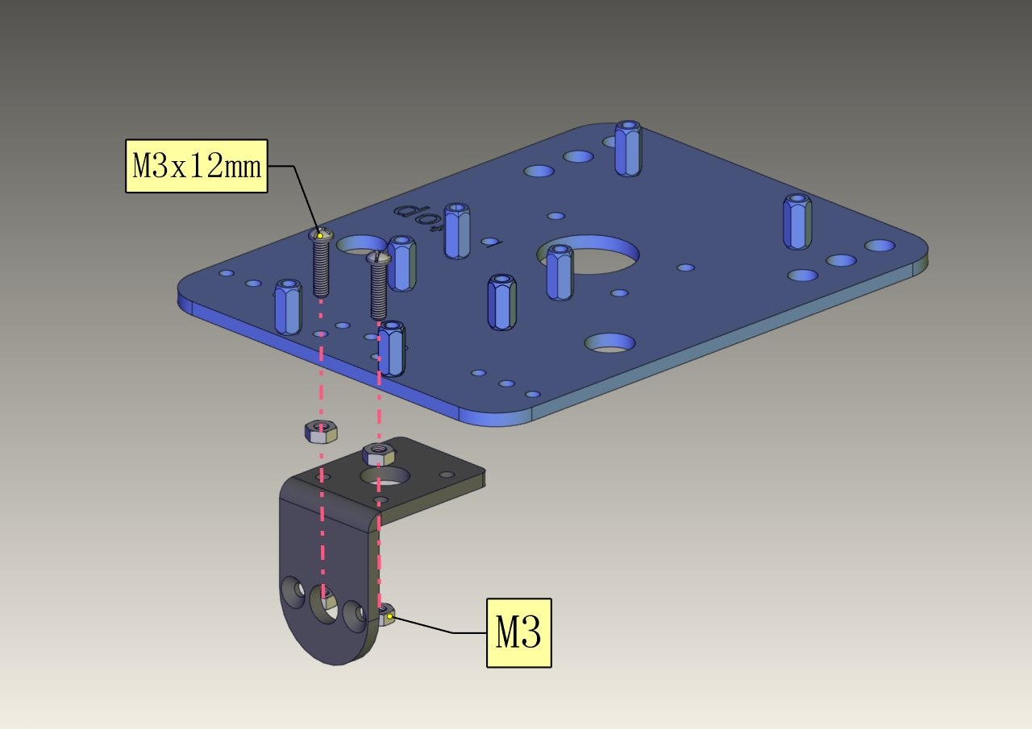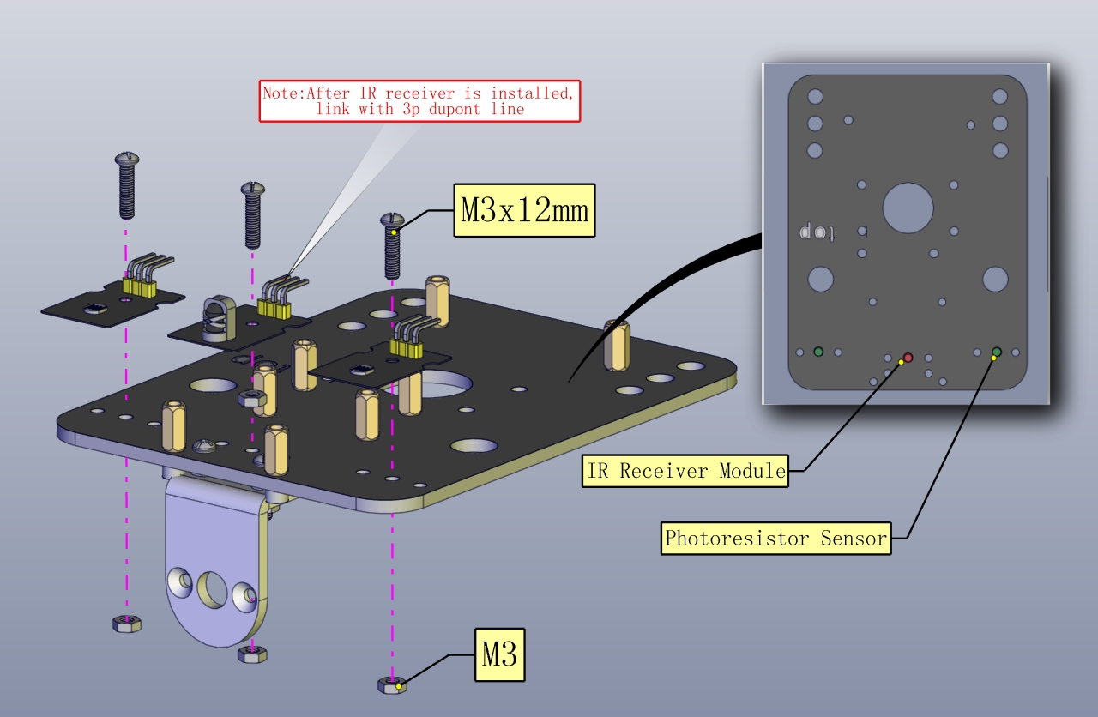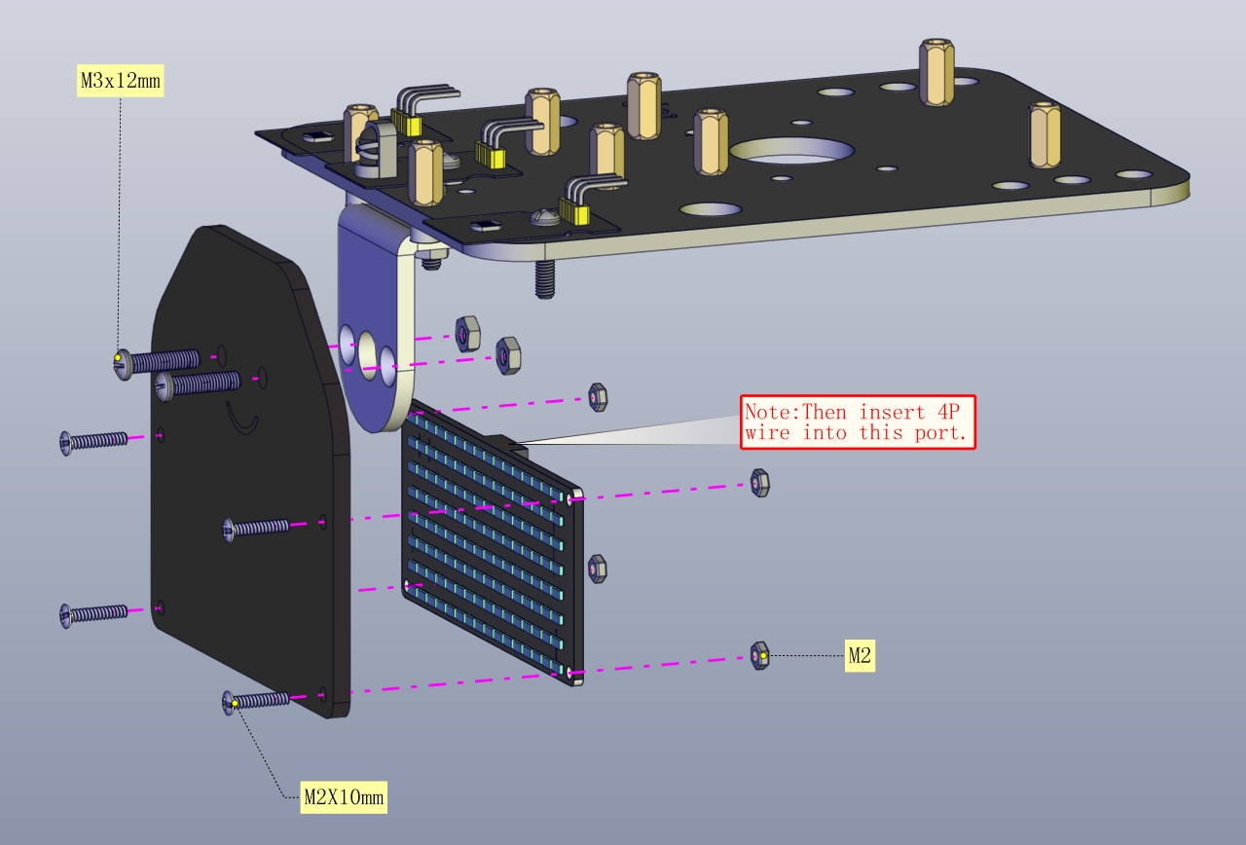

Step 5: Install the Servo Platform

Prepare the parts as follows:

* Servo *1
* Black Gimbal *1
* Cable Tie *2
* M2x8 Round Head Cross Tapping Screw *2
* Ultrasonic Sensor *1
* M2*4 Screw *1
* M1.2*5 Screw *4

Note: for convenient debugging, keep the ultrasonic module straight ahead and the angle of servo motor 90°. Therefore, we need to set servo to 90° before installing the servo platform.

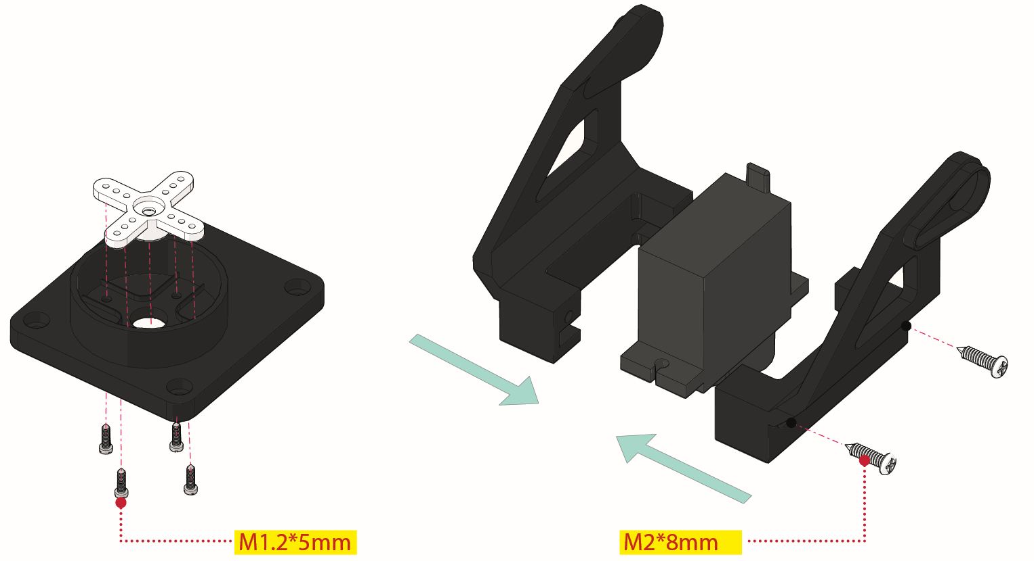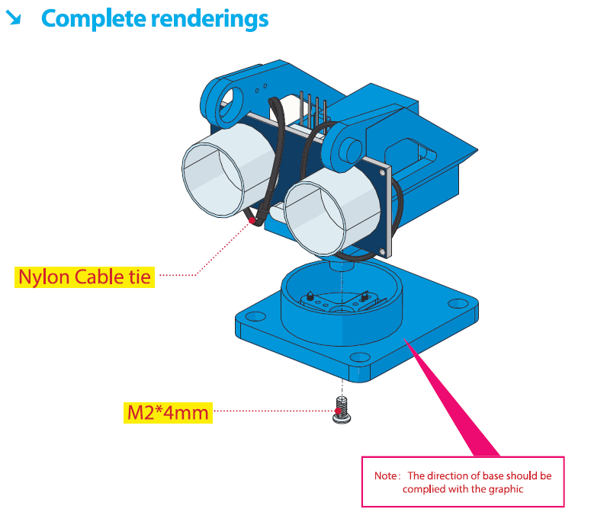

Step 6: Install Sensors and Boards

Prepare the parts as follows:

* M3*6MM Round Head Screw *12
* L298P Shield *1
* V4.0 Board *1
* V5 Sensor Shield *1
* Screwdriver *1
* Bluetooth Module *1

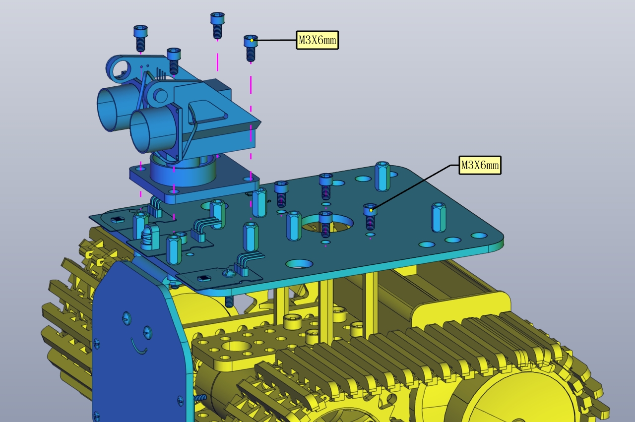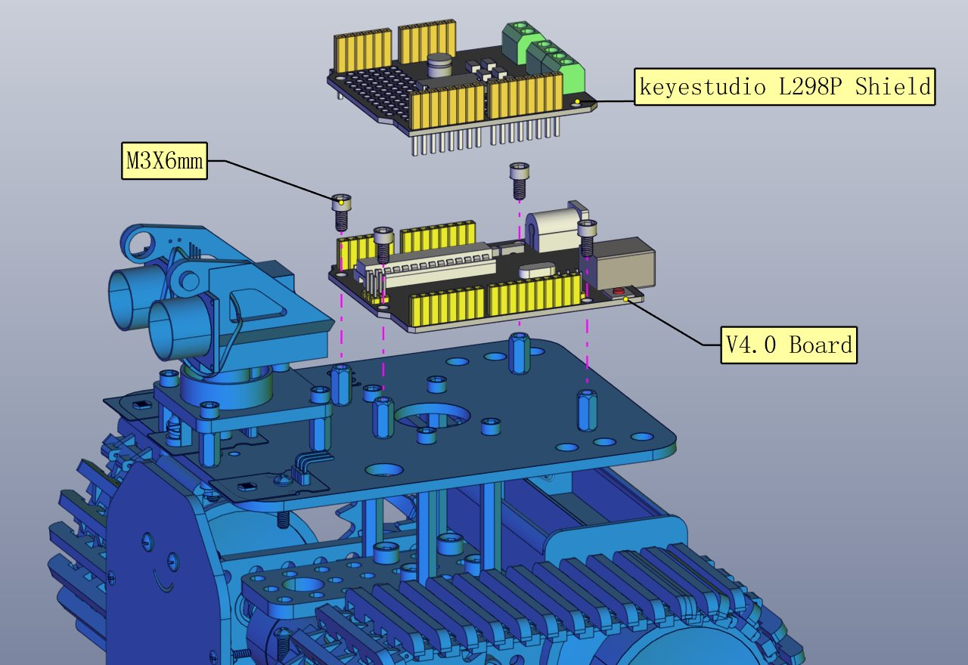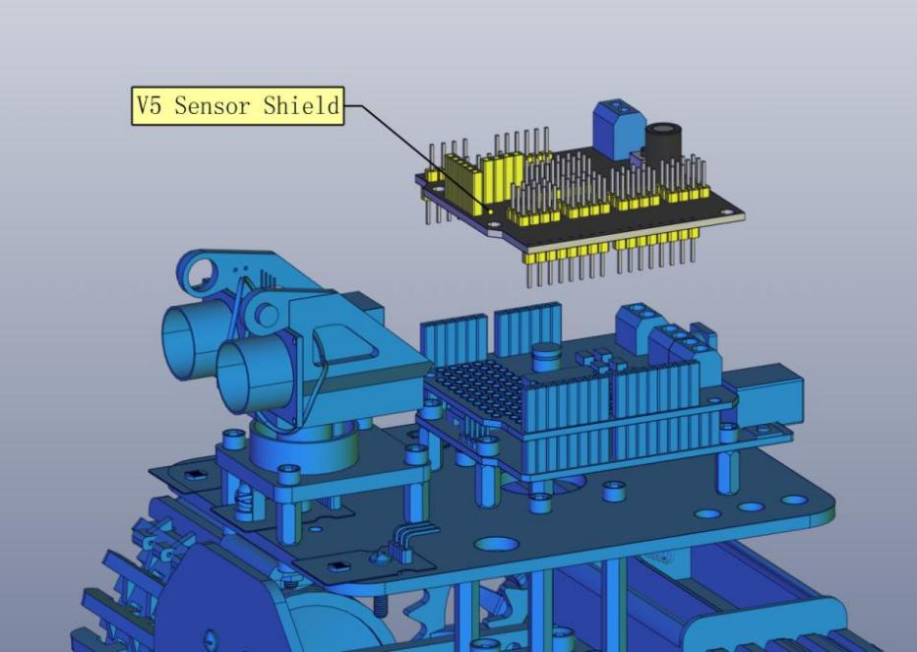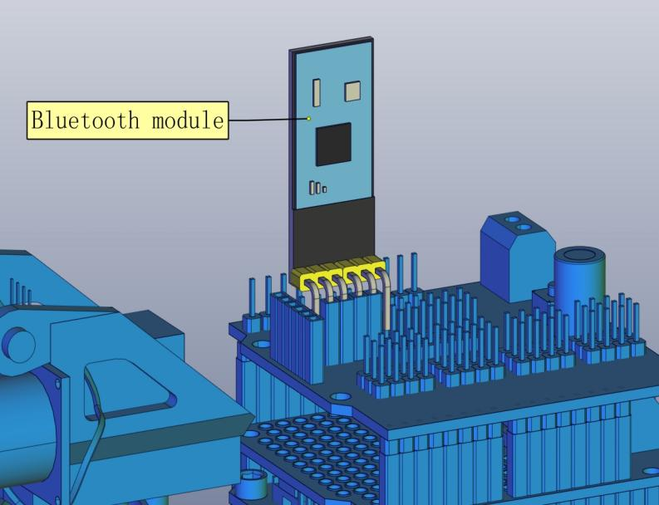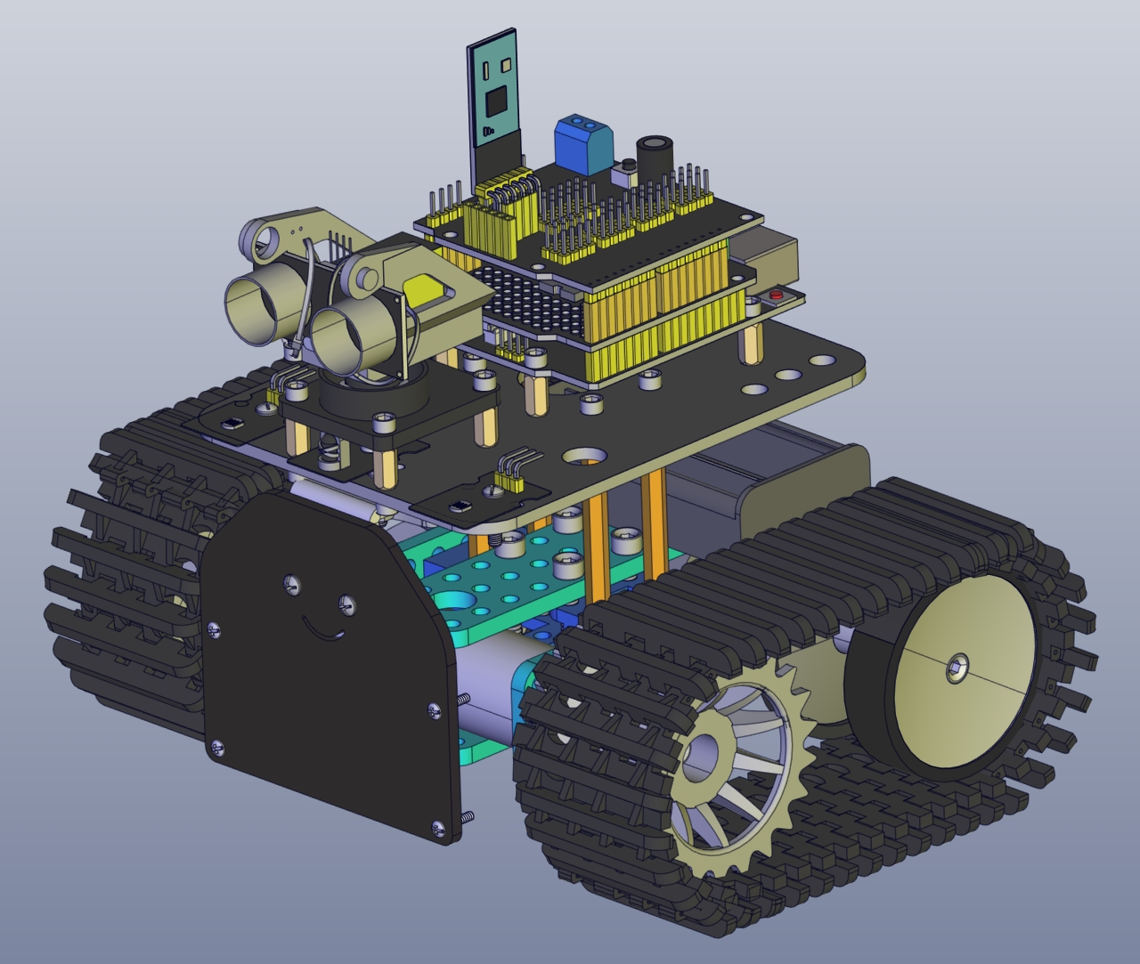

Step 7: Hook-up Guide

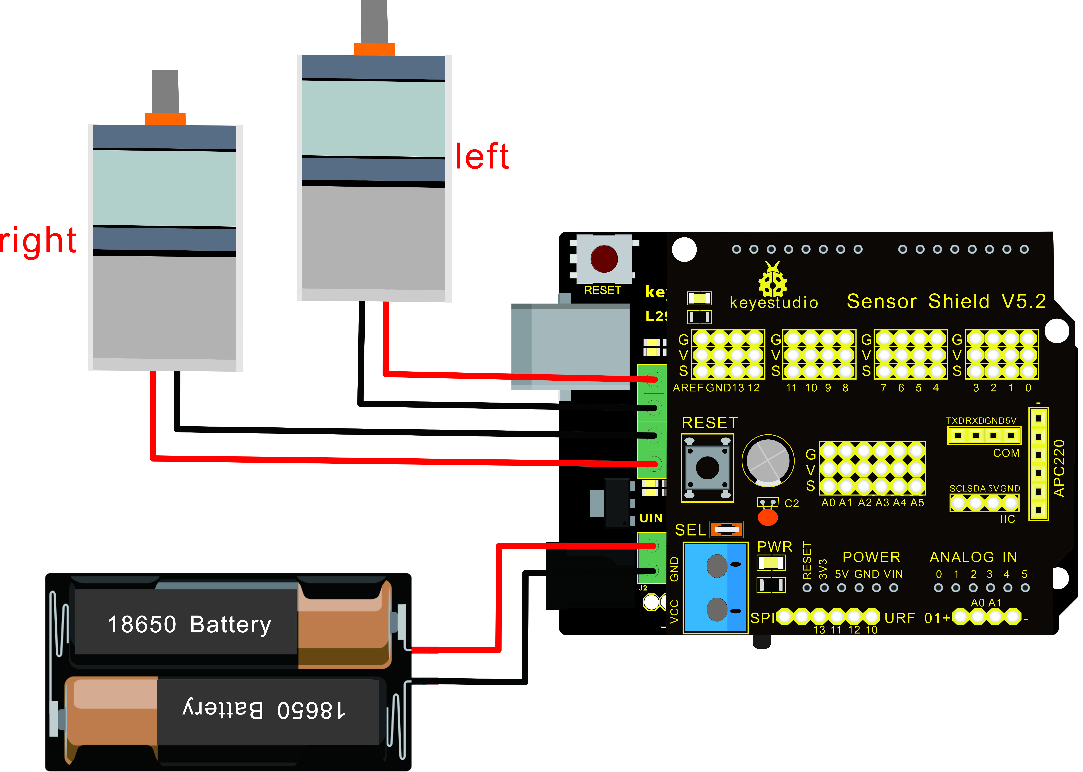

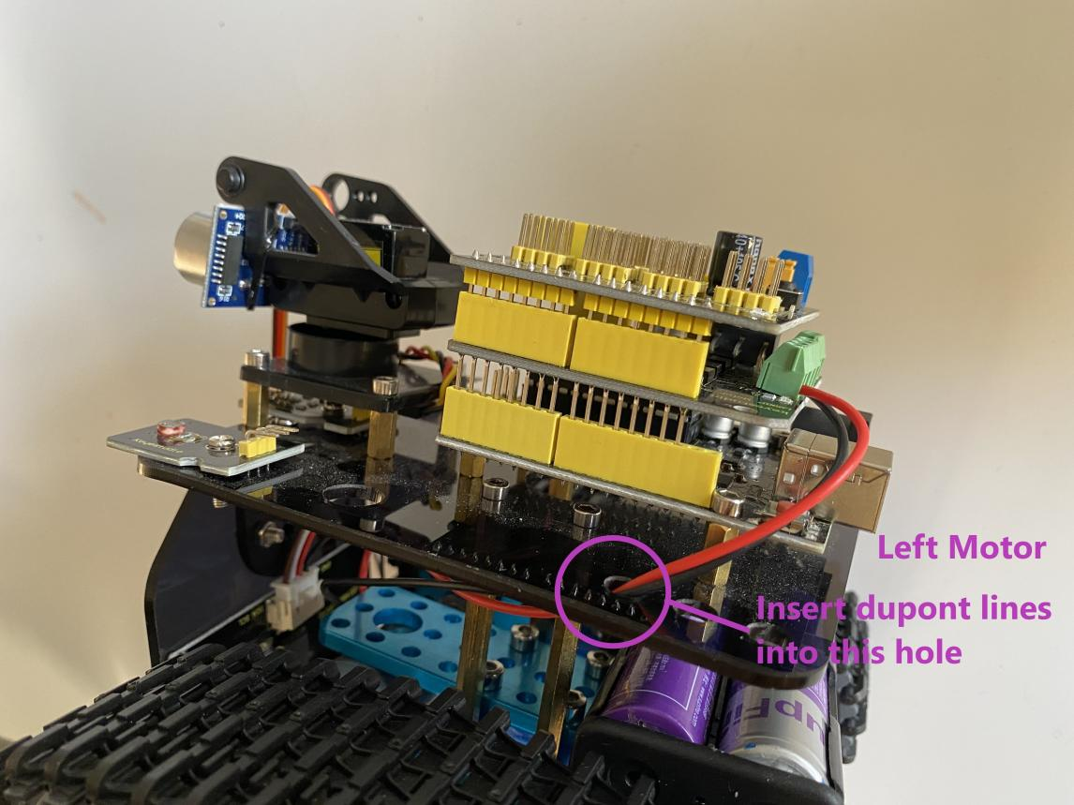

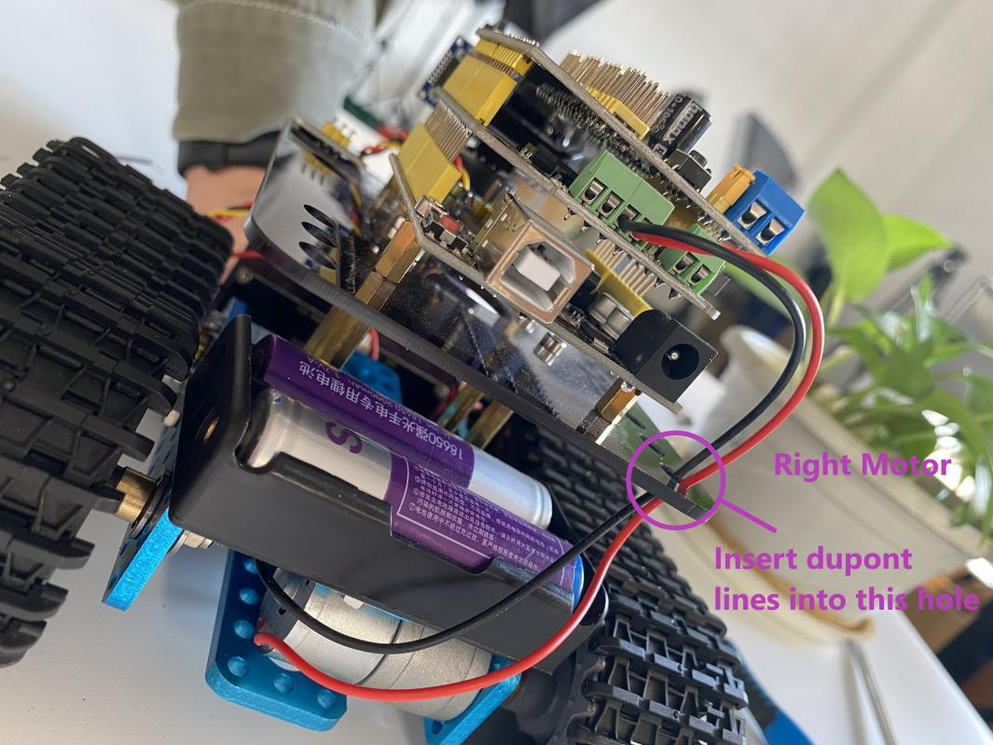

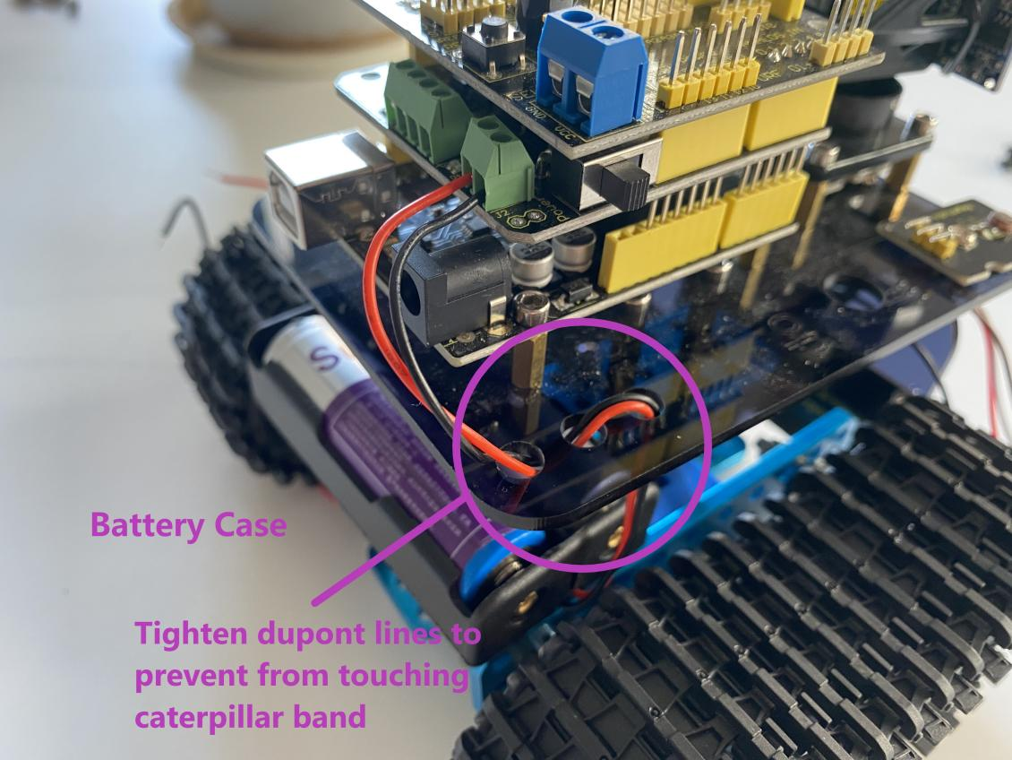

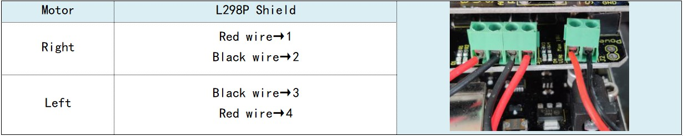

Step 8: Wire Up LED Panel

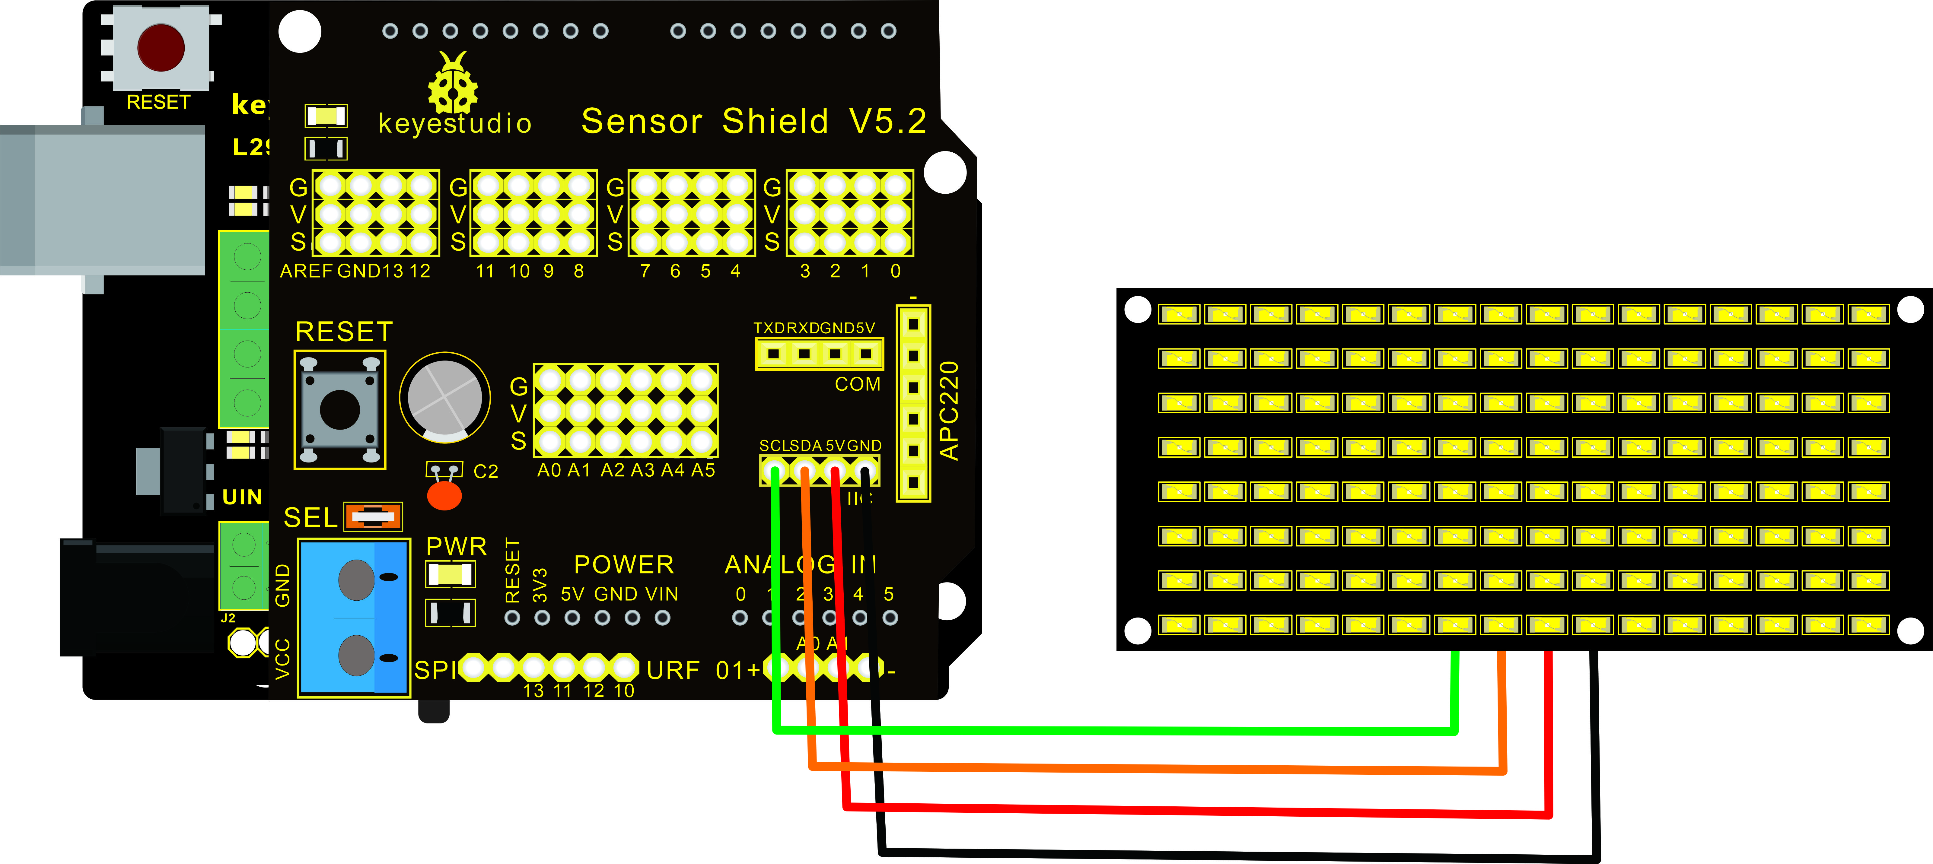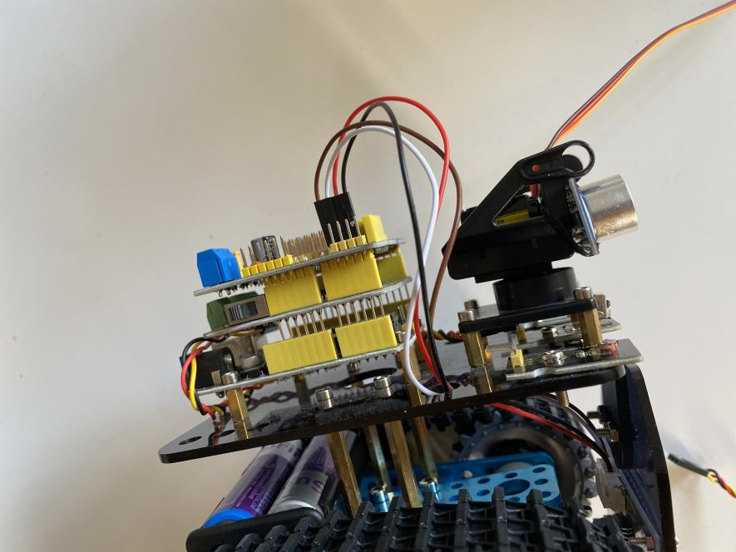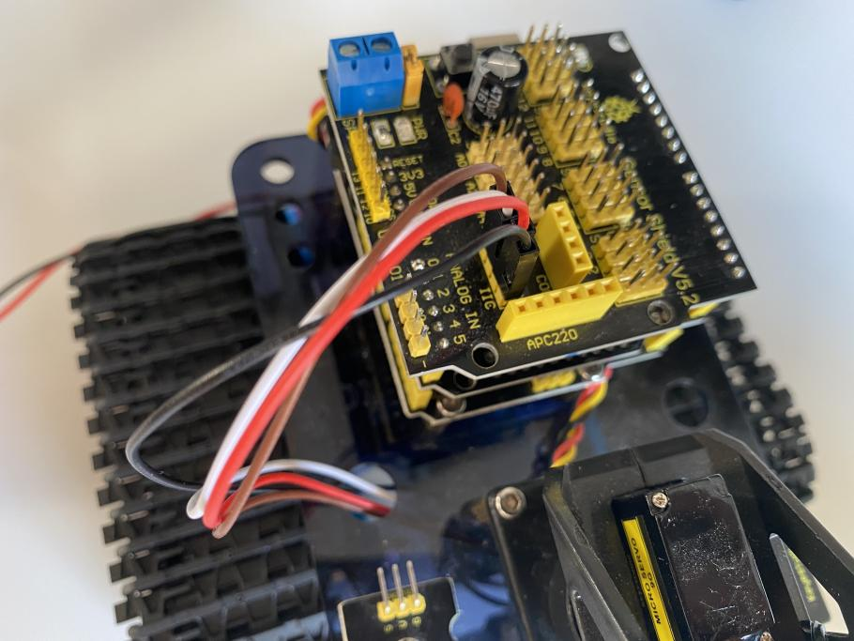

|  |  |
| --- | --- |
| LED Panel | V5 Sensor Shield |
| GND | -(GND) |
| VCC | +(VCC) |
| SDA | SDA |
| SCL | SCL |
| C:\Users\Admin\Desktop\KS0428接线\矩阵LED-1.jpg矩阵LED-1 | C:\Users\Admin\Desktop\KS0428接线\矩阵LED接线.jpg矩阵LED接线 |

Step 9: Install all parts of Acrylic plate

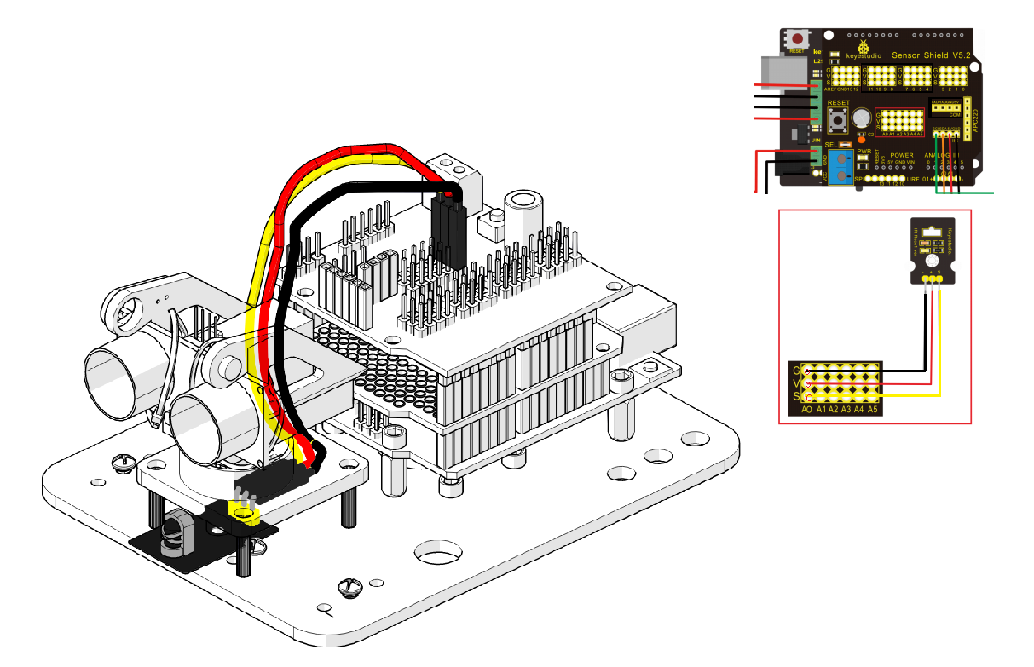

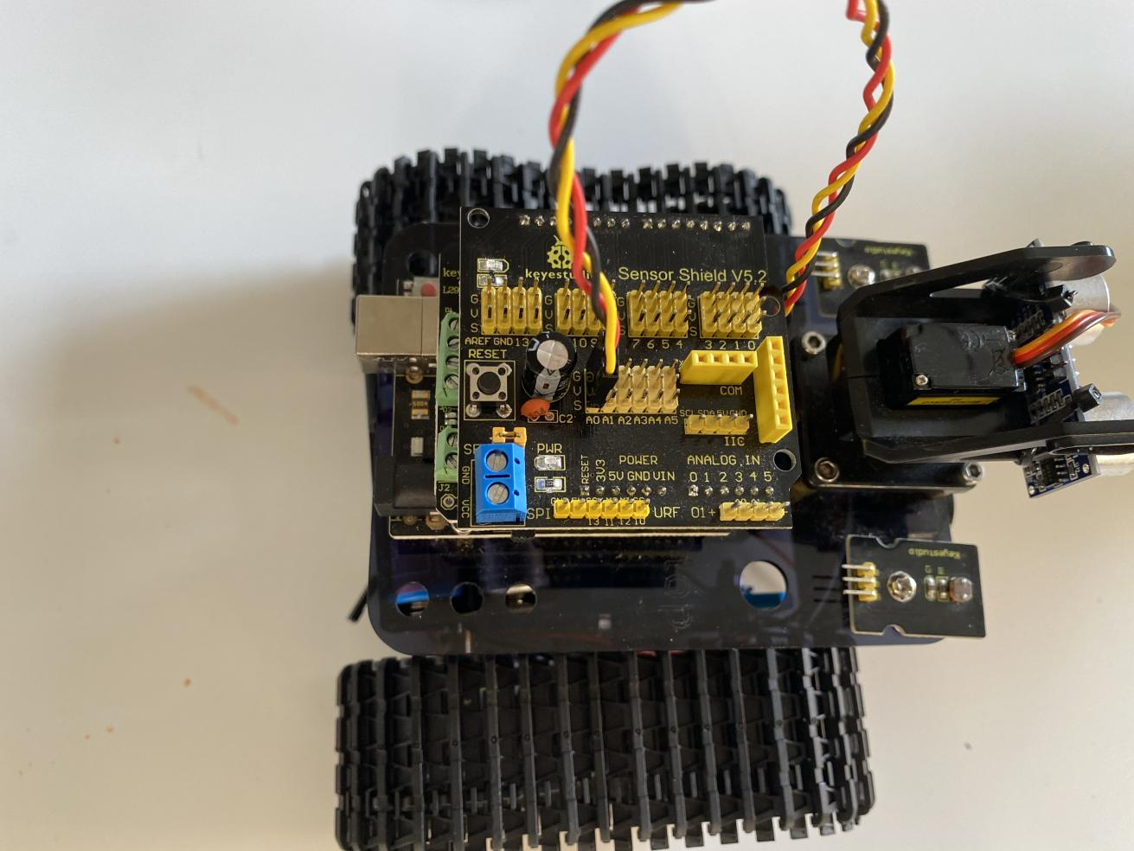

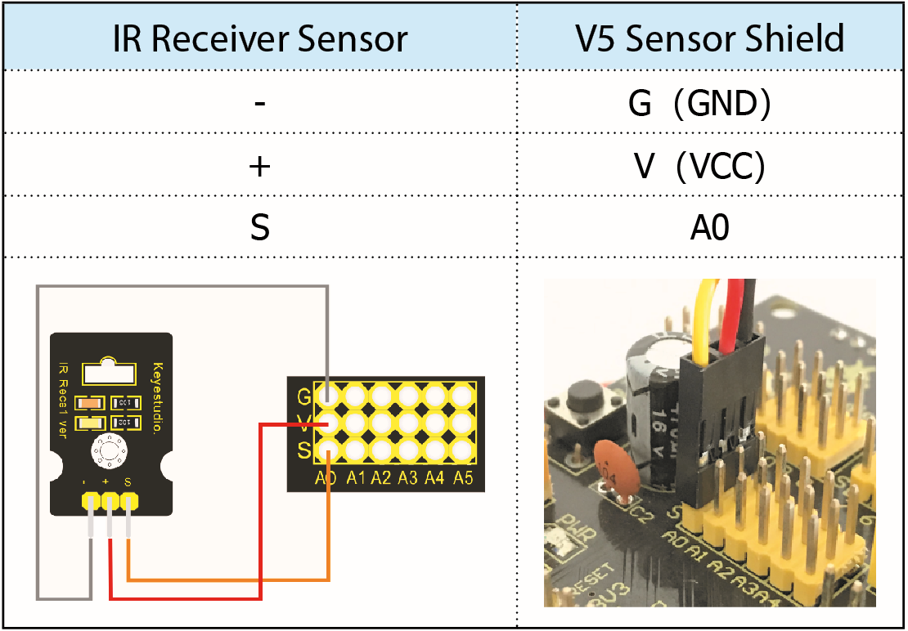

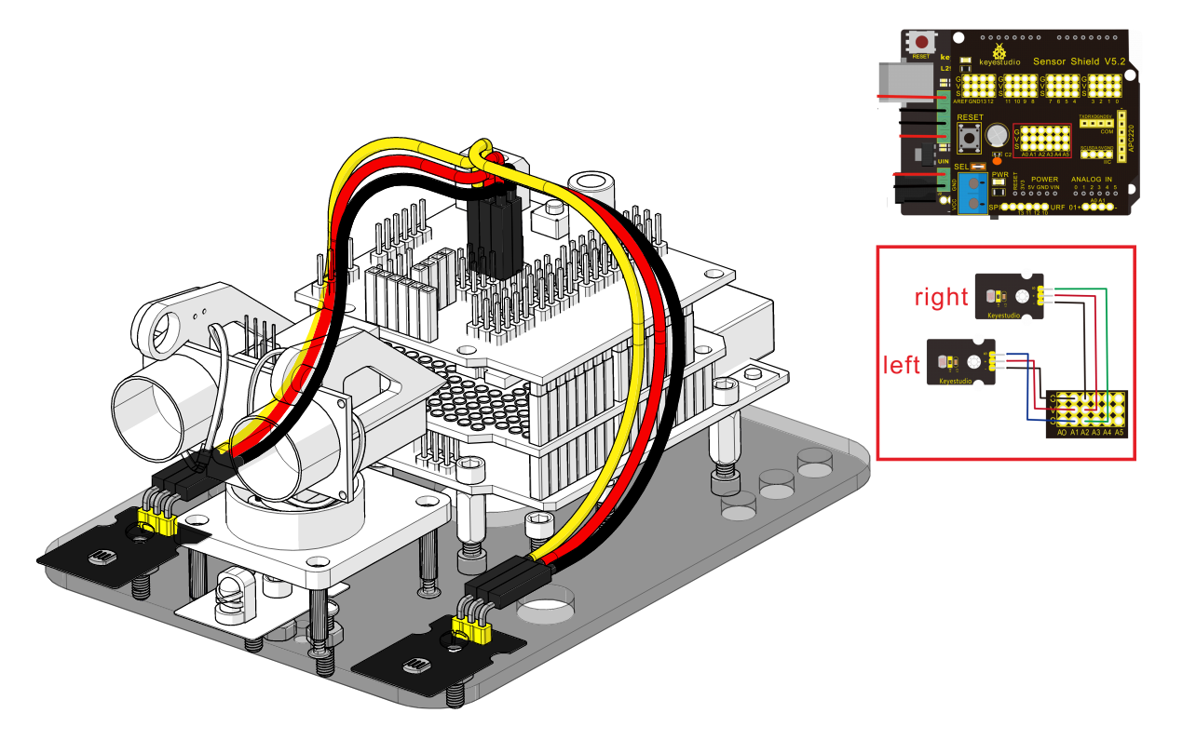

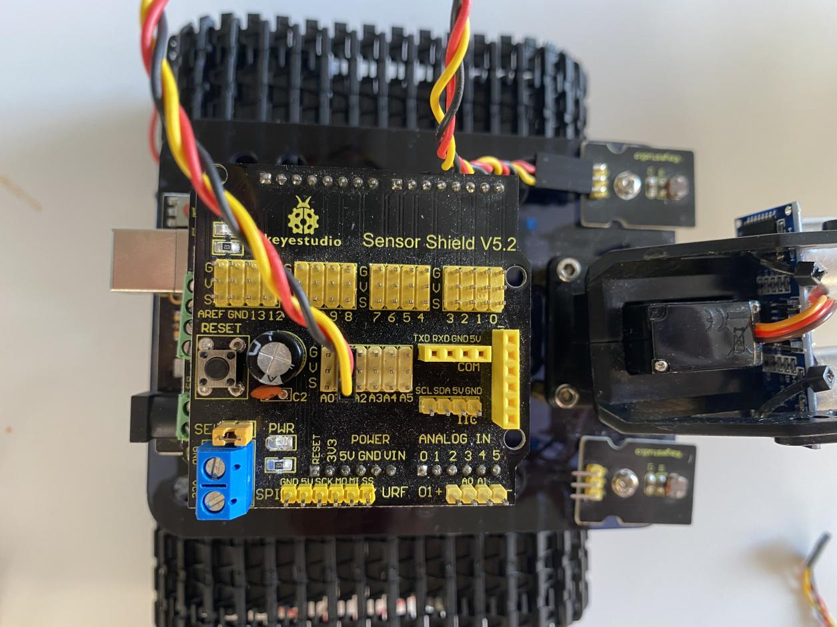

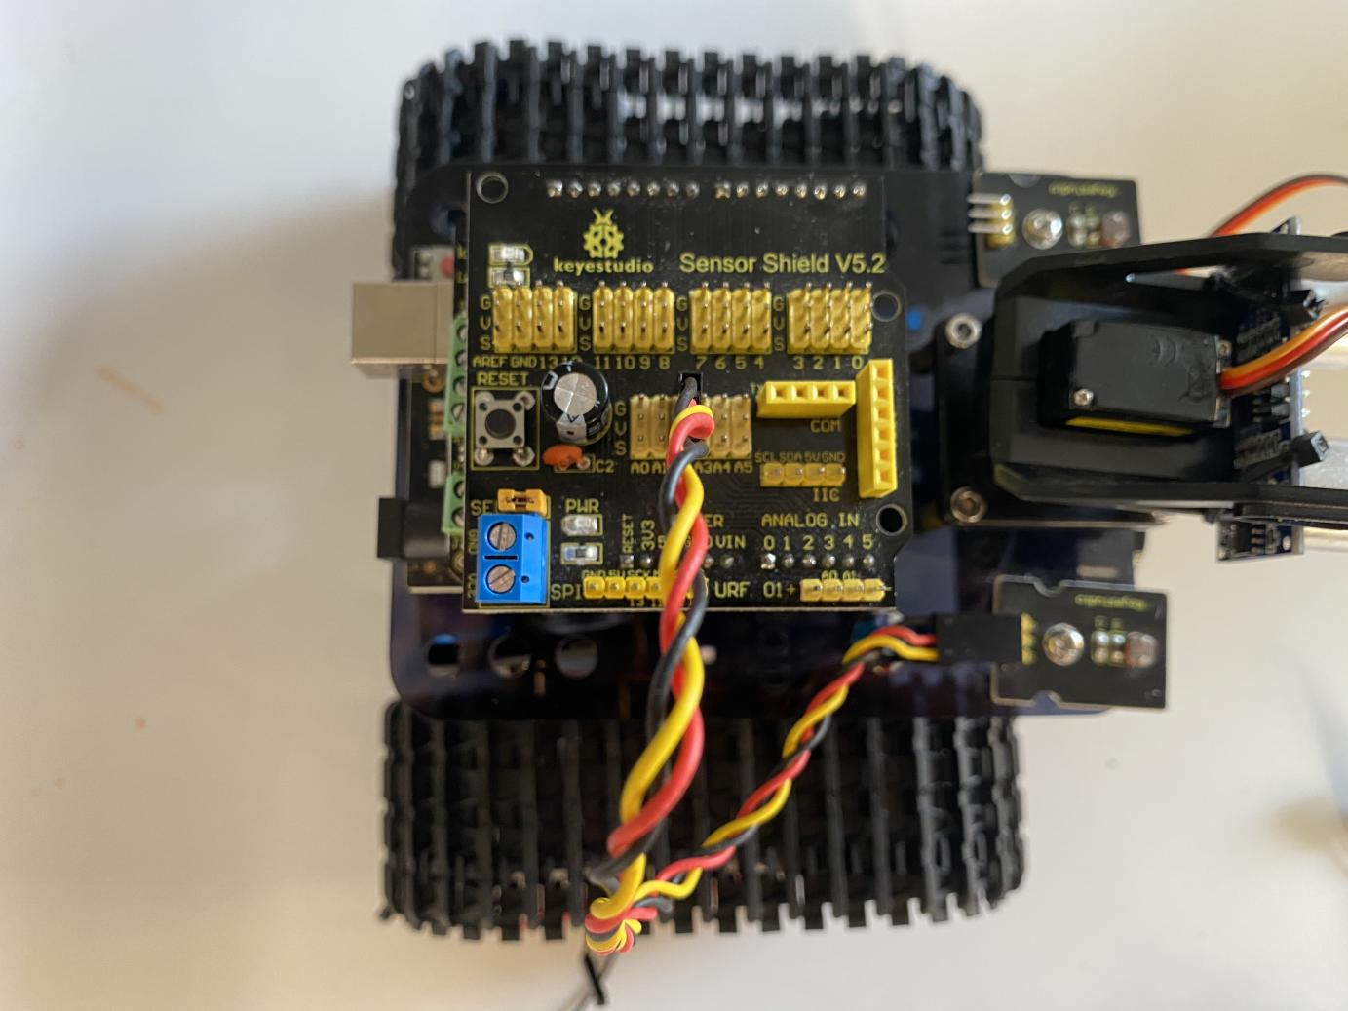

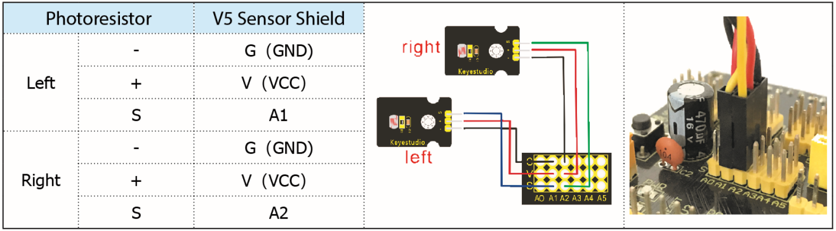

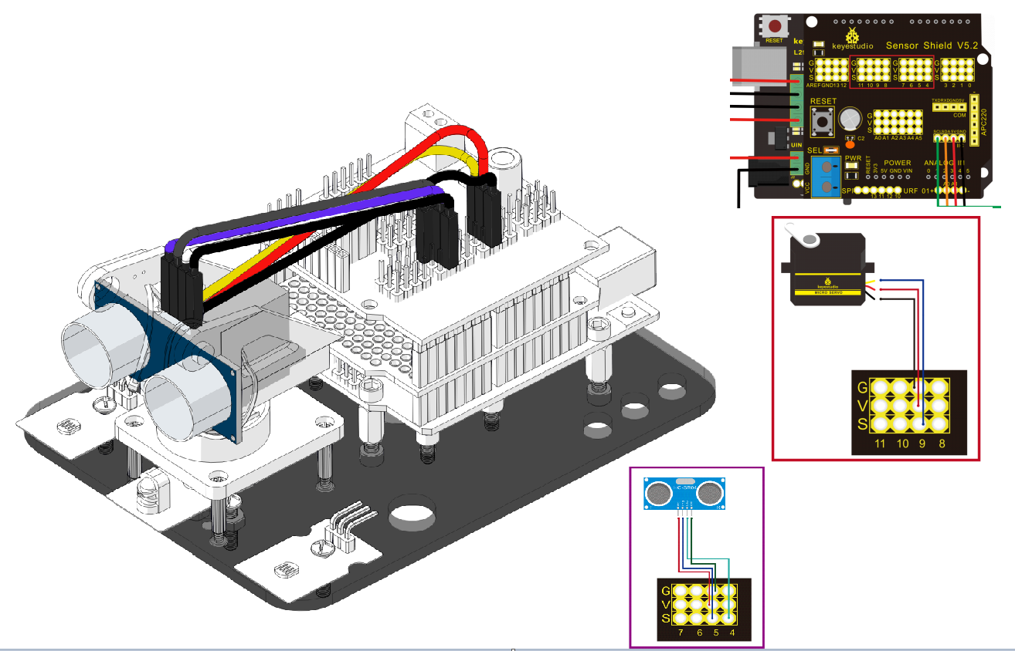

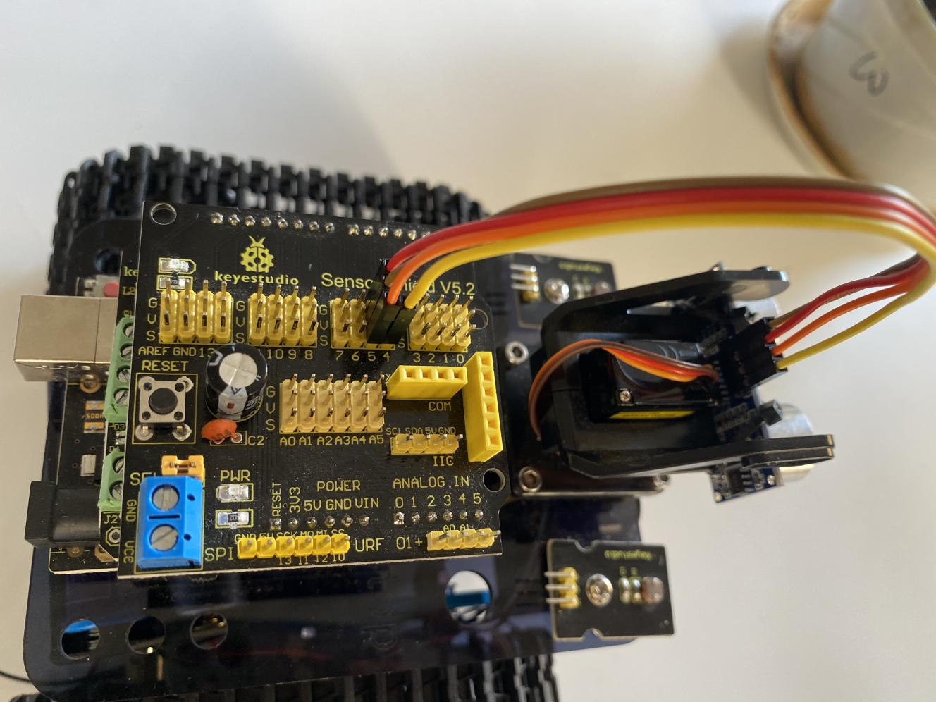

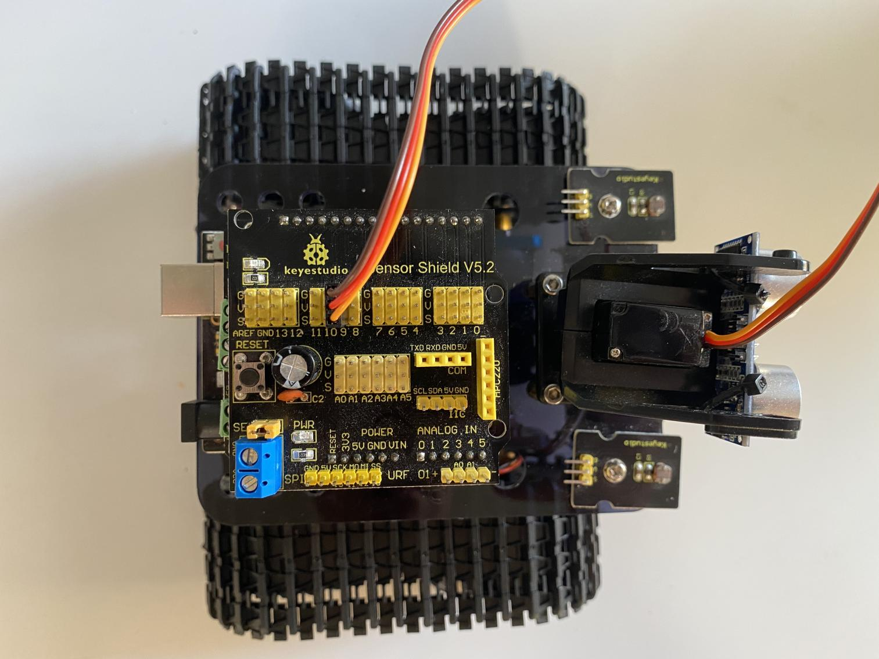

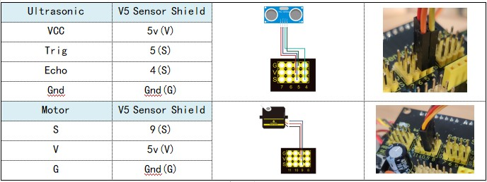

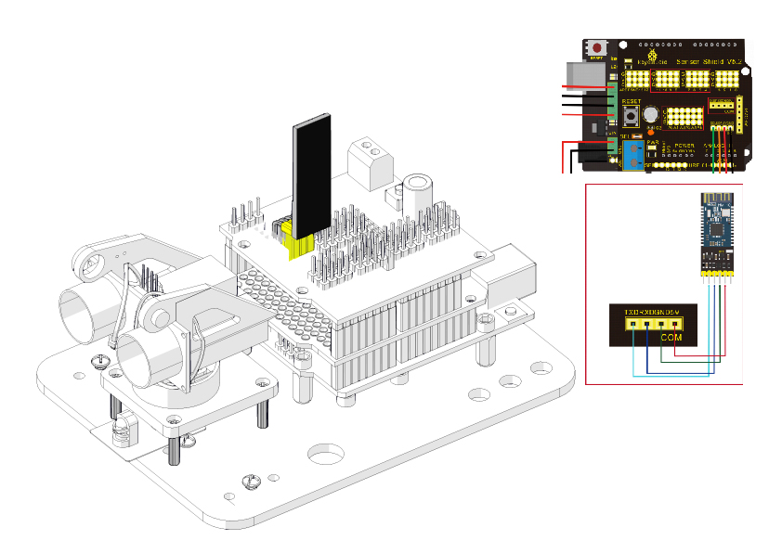

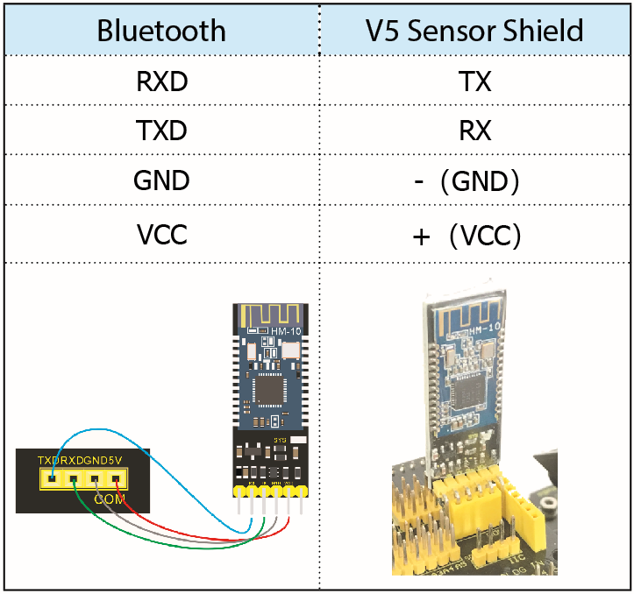

Step 10: Tank Robot

Note: Remove the Bluetooth module before uploading test code, otherwise, you will fail to upload test code.

